Chapter 8, Problem 31.

Consider the circuit in Fig. 8.79. Find v_{L}(0) and v_{C}(0).

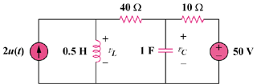

Figure 8.79
For Prob. 8.31.

